IMPORTANT TO TENANT- If you are dependent on someone in the military service of the United States or the State of New York, advise the
Court at the hearing in order to protect your rights.

JUSTICE COURT: Index No.:
COUNTY OF Orange: STATE OF NEW YORK
-------------------------------------X
25 Emerald Trail LLC
Petitioner, -against-  Nikhil D Persaud  25 Emerald Trail  Monroe NY 10950  Respondents  -------------------------------------X | NOTICE OF PETITION  EVICTION PROCEEDING  Nonpayment

To the above Respondent(s) in possession of the premises
hereinafter described or claiming possession thereof:

PLEASE TAKE NOTICE that a hearing at which you must appear will be held at the County of Orange ,Village of Blooming Grove Justice Court,6 Horton Rd, Blooming Grove NY 10914,on Thursday the 8th day of February, 2024 at 6:00 pm in the afternoon of that day, on the annexed Petition which prays for a final judgment of eviction, awarding to Petitioner the possession of the premises used for RESIDENTIAL purposes, described as
25 Emerald Trail
Monroe NY 10950

STATE OF NEW YORK, as demanded in the Petition which you must answer. Your answer may set forth any defense or counterclaim against Petitioner, unless such defense or counterclaim is precluded by law or prior agreement between the parties.

PLEASE TAKE FURTHER NOTICE the demand is made in the Petition for judgment against you for RENTS in the amount of $5700.00 through January 1, 2024 at the rate of $ 1800.00 monthly for the premises for use and occupancy that you are occupying.

PLEASE TAKE FURTHER NOTICE that if you fail to interpose and establish any defense that you may have to the allegations of the Petition, you may be precluded from asserting such defense of the claim on which it is based in other proceedings or actions as well.

Dated: January 13 , 2024 Spring Valley, NY

By:
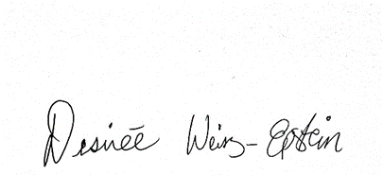
DESIREE-WEISZ-EPSTEIN, ESQ
Law offices of Desiree Weisz-Epstein, PLLC
Attorney for Petitioner
99 Union Rd, Office
Spring Valley, NY 10977
(845)445-9186

JUSTICE COURT:
COUNTY OF Orange: STATE OF NEW YORK
-------------------------------------X

25 Emerald Trail LLC
Petitioner, -against-  Nikhil D Persaud  25 Emerald Trail  Monroe NY 10950 | NONPAYMENT EVICTION  PETITION  Index No.:
Respondents

-------------------------------------X

The petition of, 25 Emerald Trail LLC

lessor and landlord of the premises respectfully shows, upon information and belief:

- Petitioner is the landlord of the premises hereinafter described and is entitled to possession of each and every part thereof.

- The premises are described as follows:
FOR RESIDENTIAL PURPOSES,
25 Emerald Trail
Monroe NY 10950
which is situated within the territorial jurisdiction of the Justice Court of the Enter Data, County of Orange. The Respondent/Tenant, Nikhil D Persaud

(hereinafter referred to as the “Respondents”), is the occupant of the premises who entered into possession under a rental agreement which has expired between the respondent and landlord therein pursuant to said agreement with respect to the premises

25 Emerald Trail
Monroe NY 10950

- The Respondents entered into possession with respect to the premises pursuant to that lease wherein Respondents promised to pay to the landlord as landlord's rent the sum of $1800.00 per month, plus applicable additional rent and landlord's legal expenses for acting with respect to the default of the tenant's obligations.

- Pursuant to the Lease, there was due to Petitioner from Respondent, as of January 1,2024, rent in the amount of $5700.00 outstanding through 01/01/2024 are as follows

October 2023 Rent 300.00
November2023 Rent $1800.00
December 2023 Rent $1800.00
January 2024 Rent $1800.00
Total $ 5700.00

- A 5 day notice and a 14 day demand for the rent have been duly made . A copy of the demands are attached hereto as Exhibit A as well as the Affidavit of Service and certified mail slip.

- Respondent is now in possession of the said premises, which is Residential in nature, and the subject premises, is located within the territorial jurisdiction of the Court.

- Notwithstanding the demand, Respondents have failed to pay such rent, which will continue to accrue until such time that possession is delivered.

- The Petitioner has no written information as to any other residence or business address of the Respondents, other than the address of the premises which are the subject of this Petition.

- The Premises are not subject to the Rent Stabilization Law of 1969 as amended by Chapter 576 of the Laws of 1974 and the Omnibus Housing Act of 1983 as this is a private house.

WHEREFORE, the Petitioner respectfully requests final judgment awarding to the Petitioner possession of the premises, a money judgment for fair value use and occupancy for rents through January 1, 2024 in the amount of $5700.00, plus any amounts accruing from use and occupancy in the amount of $1800.00 a month costs and disbursements of these proceedings and for a warrant to issue forthwith, together with such other and further relief as this Court may deem just and proper.

DATED: Spring Valley, New York
January 13,2024
BY /S/
Petitioner 25 Emerald Trail LLC

VERIFICATION

STATE OF NEW YORK ) ) ss.:
COUNTY OF ROCKLAND )

The undersigned attorney for Petitioner, hereby affirms under penalty of perjury and pursuant to CPLR 2106 that the deponent has read the petition, and that the contents of the petition are true to the deponent’s own knowledge, except as to those matters which are alleged upon information and belief, and as to such matters the deponent believes them to be true; that the deponent is the attorney for the aforesaid Petitioner; and that the grounds of my belief as to all matters which are alleged upon information and belief, and as to such matters the deponent believes them to be true; that the deponent is the attorney for the aforesaid Petitioner, and that the grounds of my belief as to all matters not stated upon my knowledge are conversations with agents of and books and records of the Petitioner.. This affirmation is made pursuant to RPAPL 741.

Dated: January 13, 2024
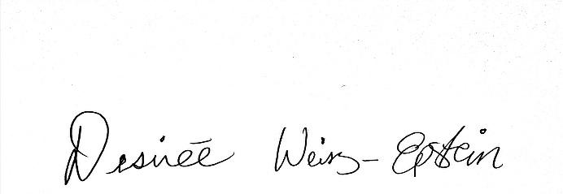
_________________________
Desiree Weisz-Epstein

NONPAYMENT PROCEEDING
INDEX NO.:

JUSTICE COURT:
COUNTY OF Orange: STATE OF NEW YORK
-------------------------------------X
25 Emerald Trail LLC

Petitioner,

-against-
Nikhil D Persaud
25 Emerald Trail
Monroe NY 10950
Respondents

X-------------------------------------X
================================================================
PETITION AND NOTICE OF PETITION
================================================================

LAW OFFICES OF DESIREE WEISZ-EPSTEIN, PLLC
DESIREE WEISZ-EPSTEIN, ESQ.
Attorney for Petitioner
99 Union Rd, Office
Spring Valley, NY 10977
(845) 445-9186

